Diabetes Risk Prediction System
Submitted In Partial Fulfilment of Bachelor of Computer Applications (BCA)

 | Submitted by:
Sanju Kumar | Kunal Singh Panwar | Aryan Kumar
23/SCA/BCA(DS&BDA)/024 | 23/SCA/BCA(DS&BDA)/018 | 23/SCA/BCA(DS&BDA)/005

Under the Supervision of:
Dr. Savita Dagar Assistant Professor



School of Computer Applications
Manav Rachna International Institute of Research and Studies
(DEEMED TO BE UNIVERSITY)
Sector-43, Aravalli Hills Faridabad – 121001

February 2026

Certificate from the Guide

This is to certify that the project report entitled “Diabetes Risk Prediction System” submitted in partial fulfilment of the degree of BACHELOR OF COMPUTER APPLICATIONS (BCA) to Manav Rachna International Institute of Research & Studies, Faridabad is an authentic and original work carried out by the following students under my guidance:
- Mr. SANJU KUMAR with Roll no. 23/SCS/BCS(DS&BDA)/024
- Mr. KUNAL PAWAR with Roll no. 23/SCS/BCS(DS&BDA)/018
- Mr. ARYAN KUMAR with Roll no. 23/SCS/BCS(DS&BDA)/005
The matter embodied in this project is genuine work done by the students and has not been submitted whether to this University or to any other University / Institute for the fulfilment of the requirements of any course of study.

Signature of the Guide

Dr. Savita Dagar Assistant Professor Faridabad

Signatures of the Students:

SANJU KUMAR

KUNAL PANWAR


ARYAN KUMAR
SIGNATURE OF HOD
Dr. Suhail Javed Quraishi HOD, SCA
Faridabad

Date:

Declaration

We do hereby declare that this project work entitled “DIABETES RISK PREDICTION SYSTEM” submitted by us for the partial fulfilment of the requirement for the award of BACHELOR OF COMPUTER APPLICATIONS (BCA) is a record of our own work. The report embodies the findings based on our study and observation and has not been submitted earlier for the award of any degree or diploma to any Institute or University.

Date:
Place: Faridabad

Signatures of the Students:

SANJU KUMAR

KUNAL PANWAR

ARYAN KUMAR

Acknowledgement

We would like to express our profound gratitude to our project guide, Dr. Savita Dagar, Assistant Professor, for her valuable guidance, continuous encouragement, and constant support throughout the development of our project titled “DIABETES RISK PREDICTION SYSTEM”. Her deep insights and feedback helped us immensely in completing this project successfully.
We are also highly thankful to Dr. Suhail Javed Quraishi, HOD (SCA), for providing us with the necessary resources and an encouraging environment to carry out this project work.
Furthermore, we would like to thank the faculty and staff of Manav Rachna International Institute of Research & Studies, Faridabad, for their indirect but significant support during our Bachelor of Computer Applications (BCA) program.
Finally, we would like to thank our parents, friends, and each other as a team for the seamless coordination and motivation that made this project a reality.

Date:
Place: Faridabad

Signatures of the Students:

SANJU KUMAR

KUNAL PANWAR

ARYAN KUMAR

INDEX

S.  No. | Topic | Page  No.:
1 | Introduction
1.1 | Problem Statement
1.2 | Objectives
1.3 | Scope of the Project
2 | Literature Review
2.1 | Existing Systems
2.2 | Proposed Solution & Enhancements
3 | System Analysis & Design
3.1 | Hardware & Software Requirements
3.2 | System Architecture
3.3 | Data Flow Diagrams (DFD) & Use Cases
3.4 | Entity-Relationship (ER) Diagram
4 | Implementation
4.1 | Dataset Description & Exploratory Data Analysis (EDA)
4.2 | Data Preprocessing (Handling Zeroes & Scaling)
4.3 | Machine Learning Algorithm (SVM)
4.4 | Web Application & Database Integration
5 | Results & Evaluation
5.1 | Model Evaluation Metrics
5.2 | Output Generation & PDF Reports
6 | Conclusion, Limitations & Future Scope
7 | References

INTRODUCTION

  - Problem Statement
- Identified Problem: Diabetes Mellitus is a global health issue which is seem to be growing at great speed. It is marked by high blood sugar levels which in fact is long term. If it remains undetected and untreated that is when it tends to be the agent which sets off very serious and permanent health issues which in turn include heart disease, kidney failure, neuropathy, and retinal damage.
Despite that early detection is a must, the present health care diagnostic system is very much at a standstill. We have a routine which sees patients scheduled in for clinical visits, put off food for testing, give out blood samples which then go to the lab for analysis a process which is very time and again also very hard on the pocket. For people in remote areas or in underserved communities this lack of access to health care facilities is a great issue. By the time they do go to the hospital due to severe symptoms the disease has often progressed to a serious stage. Also, modern day doctors’ and clinic are very over run which in turn puts forth a great need for an auto tuned triage system which is able to identify high risk patients before they go to the hospital.

- Problem Definition: To design, develop and roll out a secure cross platform Machine Learning based web application which we have named the “Diabetes Prediction System”. This application will use the Support Vector Machine (SVM) classification algorithm to look at eight input variables from the user at any given time (for instance Glucose, BMI, Insulin, and Age). By looking at these health indicators in relation to past trends the system is to determine the patient’s present risk of diabetes and to put out very accurate early warning which will go right to the patient’s personal device in real time.

  - Objectives
- Predictive Accuracy: To train, test and optimize a Support Vector Machine (SVM) model with the PIMA Indians Diabetes dataset. We aim to achieve high accuracy and recall which in turn will reduce “False Negatives” that are very much so in a medical screening context. Also we will put in place robust data preprocessing pipelines which include use of median imputation for invalid zero values and we also will do standard scaling (Standard Scaler) to even out the feature weights.
- User Accessibility: To develop a smooth, responsive frontend web app with the Streamlit framework. The goal is to remove the tech barrier, which will see users of all age groups and tech proficiencies be able to input their medical info and get immediate feedback which they do not have to understand the code behind it.
- Data Integrity: To implement a secure cloud-based NoSQL database using MongoDB. Instead of acting as a one-time calculator, the objective is to create a true user ecosystem where patient profiles

are authenticated, and all historical prediction records are securely logged and timestamped for future medical reference.
- Automated Reporting: To generate immediate, tangible value for the user by dynamically generating professional, downloadable PDF medical reports (utilizing the reportlab library). These reports will summarize the inputted vitals, clearly state the algorithmic prediction, and provide AI-generated lifestyle recommendations that the patient can directly share with a certified physician.

  - Scope of the Project
Establishing the boundaries of the project is crucial to understanding its real-world application.
- What the system covers: The project acts as a robust, preliminary early-warning screening tool. It successfully performs binary classification (Diabetic vs. Non-Diabetic) based solely on eight specific physiological features. The application is entirely platform-independent; because it is deployed as a web application, it functions seamlessly across desktop computers, tablets, and mobile smartphones (Android and iOS) using any standard web browser. It encompasses user authentication, cloud data storage, and automated document generation.
- What the system does not cover: This system is explicitly not a definitive clinical diagnostic device, nor does it replace the expertise of a medical professional. It does not prescribe medications, calculate insulin dosages, or screen for other related metabolic diseases (e.g., thyroid disorders). The accuracy of the prediction is strictly bounded by the accuracy of the self-reported data entered by the user.

Literature Review

  - Existing Systems
Historically, predictive modelling in healthcare has relied heavily on localized software and theoretical academic research. A thorough review of existing literature and available tools reveals several critical limitations in how diabetes prediction has been handled thus far:
- Algorithmic Focus Over Deployment: Numerous researchers have utilized the PIMA Indians Diabetes dataset to train various machine learning models, including Decision Trees, Naive Bayes, Logistic Regression, and Random Forests. While these models often achieve respectable accuracy, the vast majority of these projects remain confined to local development environments (such as Jupyter Notebooks). They are rarely deployed as usable software for non-technical users.
- Stateless and Transient Applications: The few predictive calculators that do exist online are typically “stateless.” This means they function as simple input-output calculators that do not retain user information across sessions. If a patient wants to track their risk over time, they must re-enter all their medical vitals from scratch upon every visit.
- Lack of Data Persistence and Security: Existing academic prototypes generally lack backend database integration. They do not offer secure user authentication (login/registration) or cloud-based data storage, making them unsuitable for real-world clinical use where tracking patient history is essential.
- Absence of Tangible Documentation: Current systems usually display the final prediction as a simple line of text on a screen. They fail to provide printable, professional documentation (like a medical report) that a patient can physically take to an endocrinologist or general physician for further consultation.

  - Proposed Solution & Enhancements
To bridge the massive gap between raw data science and practical healthcare technology, this project introduces a holistic, end-to-end web application. It transitions predictive analytics from a purely mathematical concept into a viable Software-as-a-Service (SaaS) healthcare product. The proposed system introduces the following major enhancements:
- Highly Optimized Machine Learning Pipeline: Unlike basic implementations, this project utilizes a highly optimized Support Vector Machine (SVM) with a linear kernel. Crucially, the system implements rigorous data preprocessing—invalid zero values (e.g., Blood Pressure or Glucose of 0) are intelligently replaced with column medians, and a StandardScaler is applied to normalize the feature weights. This ensures the model does not produce biased predictions based on vastly different metric scales.

- Stateful Cloud Database Integration: By incorporating MongoDB Atlas (a NoSQL cloud database) via pymongo, the application transforms from a stateless calculator into a stateful, personalized tracking tool. It features secure user registration and logs every single prediction securely. This data persistence allows the system to assign unique IDs to each user and maintain a historical ledger of their health assessments.
- Modern, Cross-Platform UI: The system leverages the Streamlit framework to deliver a highly responsive, modern web interface. Because the processing happens on the server side, the application is inherently cross-platform—allowing patients or doctors to access the tool seamlessly from an Android smartphone, an iPhone, or a desktop computer without downloading any external software.
- Automated PDF Medical Reports: To provide immediate, tangible value to the user, the report lab library is integrated directly into the prediction pipeline. Upon calculating the result, the system automatically constructs an in-memory, downloadable PDF document. This report includes a structured table of the patient’s inputted vitals, the algorithmic diagnosis, tailored lifestyle recommendations, and standard medical disclaimers—effectively mimicking the output of professional medical software.

System Analysis and Design

  - Hardware & Software Requirements
To accurately reflect the modern, cross-platform architecture of this web-based application, the system requirements are categorized into two distinct environments: the Server-Side (Development Environment) where the model is trained and hosted, and the Client-Side (End-User Environment) where the patient or medical professional accesses the tool.
    - Server-Side / Development Environment Requirements
This environment is used by the developer to process the dataset, train the Support Vector Machine (SVM) model, build the Streamlit backend, and manage database connections.
- ​Hardware Requirements:

Processor (CPU) | Intel Core i3 / i5 / i7 (or AMD Ryzen equivalent).
Random Access Memory (RAM) | Minimum 8 GB (16 GB recommended).
Storage | Minimum 256 GB Solid State Drive (SSD).
- ​Software Requirements:

Operating System | Windows 10/11, macOS, or a Linux distribution (64-bit  architecture).
Programming Language | Python (Version 3.8 or higher).
Web Framework | Streamlit (v1.29.0)
Machine Learning & Data  Processing | Scikit-learn (v1.4.2)
Database Management | MongoDB Cloud (Atlas) and the pymongo (v4.6.3) library
Report Generation | Reportlab (v4.2.0)
IDE | Visual Studio Code (VS Code) or Jupyter Notebook.

    - Client-Side / End-User Environment Requirements
Because the heavy computational lifting (data scaling and ML prediction) is entirely offloaded to the server, the client-side requirements are extremely lightweight, making the application highly accessible.

​Hardware Requirements:
  - Device: Any internet-enabled smart device. This includes:
    - Smartphones (Android or Apple iOS)
    - Tablets (iPads, Android Tabs)
    - Personal Computers (Desktop or Laptop)
  - Processing & Memory: No specific CPU or RAM constraints are placed on the user's device, as the browser only acts as a display client for the Streamlit UI.

​Software Requirements:
  - Operating System: Platform-independent (Functions seamlessly across Android, iOS, Windows, macOS, and ChromeOS).
  - Web Browser: Any modern, updated web browser that supports HTML5. Recommended browsers include:
    - Google Chrome
    - Apple Safari
    - Mozilla Firefox
    - Microsoft Edge
  - Network Connectivity: A stable Wi-Fi or cellular internet connection (3G/4G/5G).

System Architecture
The application follows a standard client-server-database architecture. The user interacts with the frontend (Streamlit), which sends data to the Python backend. The backend scales the data, queries the ML model (diabetes_model.pkl), logs the transaction in MongoDB, and returns the result and PDF.

Data Flow Diagrams (DFD) & Use Cases
- Level 0 DFD: The User inputs their credentials and medical vitals into the system and receives a prediction and PDF report.
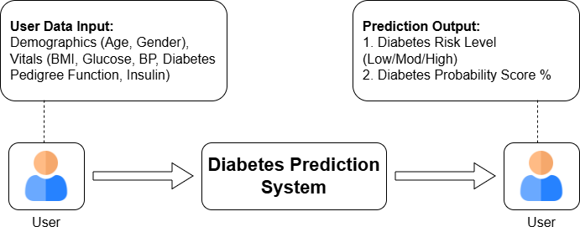

Fig 1: Level 0: DFD Diabetes Risk Prediction System

- Level 1 DFD: This Level-1 Data Flow Diagram represents the step-by-step processing of user health data through validation, feature processing, machine learning, probability calculation, and risk classification to generate a diabetes prediction result.

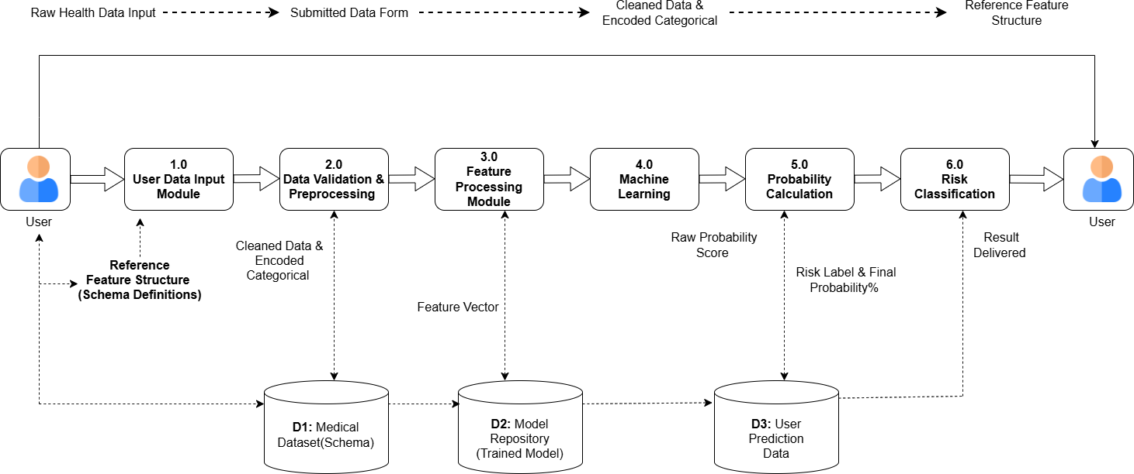

Fig 2: Level 1: DFD Diabetes Risk Prediction System

Entity-Relationship (ER) Diagram
Although the application utilizes MongoDB (a NoSQL document database), mapping the logical data structure is crucial for system design. The database diabetes_app consists of two primary entities that share a One-to- Many (1:N) relationship: one user can have multiple prediction records.
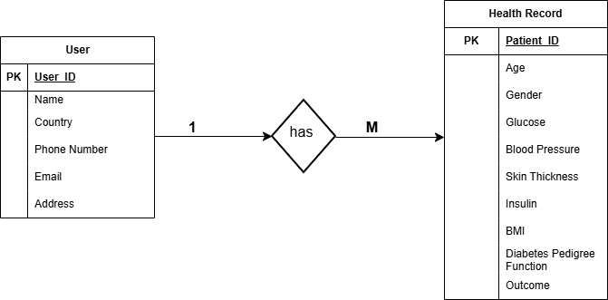
Fig 3: Entity-Relationship (ER) Diagram

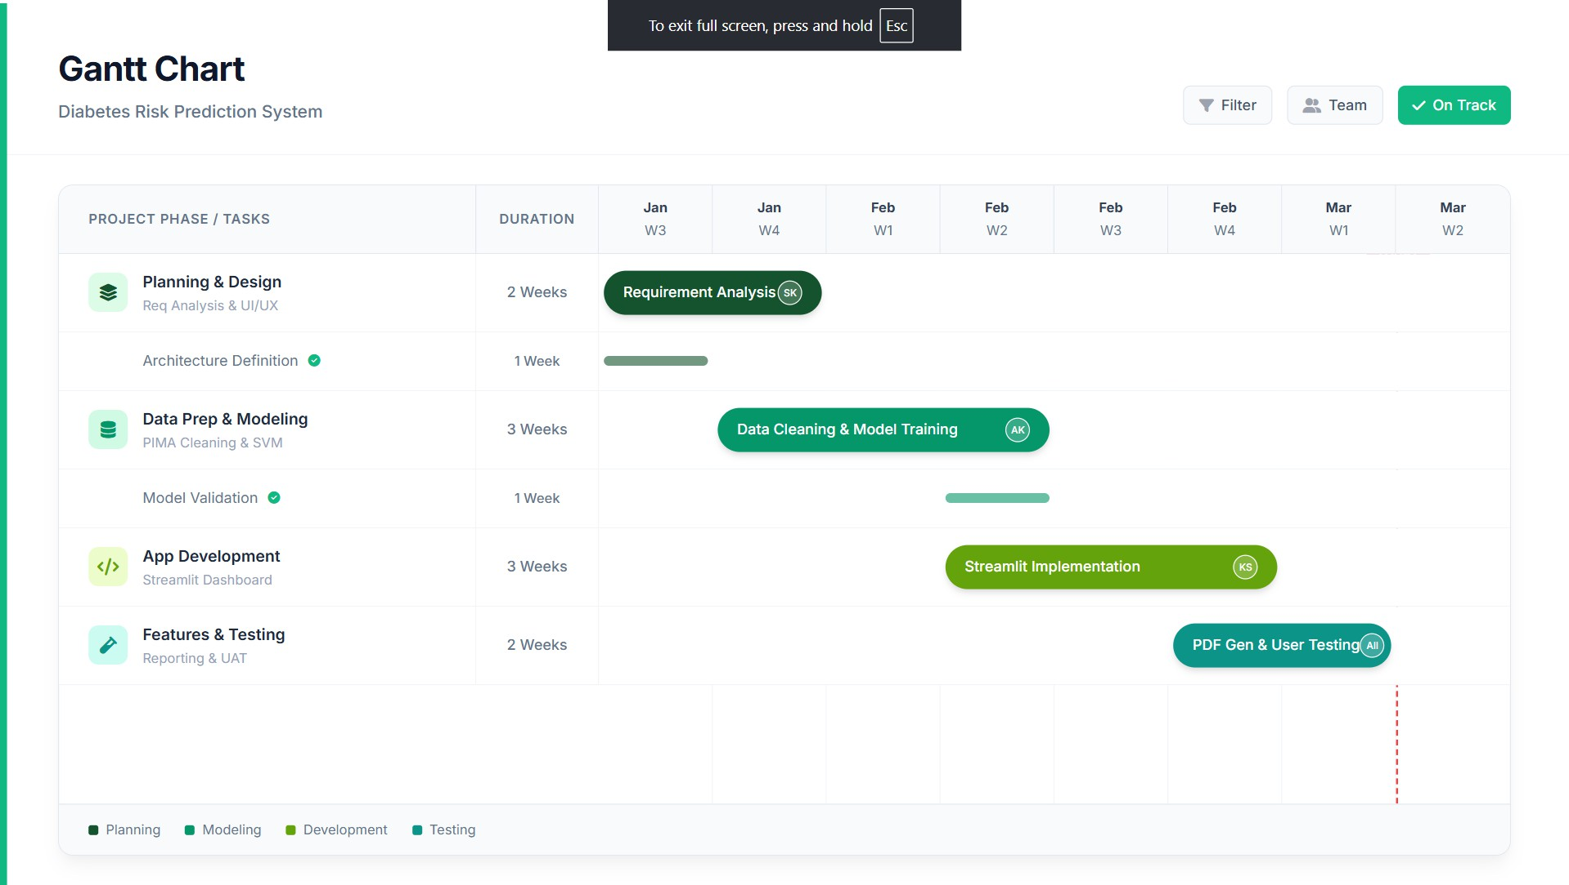
Fig 4: Gantt Chart

IMPLEMENTATION

Dataset Report and Exploratory Data Analysis (EDA)
The project uses the PIMA Indians Diabetes Database, which includes 8 clinical variables and 1 target variable (Outcome). In the EDA we created correlation matrices and distribution plots to study feature relationships. We found Glucose and BMI to have the strongest correlation with the target variable.

Data Preprocessing (Handling Zeroes & Scaling)
- Imputation: Invalid 0 values (for example Blood Pressure of 0) were replaced with the median of respective columns’ values to prevent skew in training.
- Standardization: Because there is large scale variation in features StandardScaler was applied for standardization of the dataset. The fitted scaler was saved as scaler_svm.pkl to process real time user inputs.

Machine Learning Algorithm (SVM)
A Support Vector Machine (SVM) which uses a linear kernel. In the SVM the algorithm identifies the best hyperplane which maximizes the gap between Diabetic and Non-Diabetic classes. What we do is to find out the weight vector $w$ and bias $b$ which maximize the margin subject to the class separation. The trained model was serialized using joblib (diabetes_model.pkl).

Web Application & Database Integration
- Frontend: Developed using Streamlit to handle routing and input forms.
- Database: Connected to MongoDB Atlas via pymongo. The two collections mapping to our ER Diagram registered_users and predictions securely store credentials and patient histories.

RESULTS & EVALUATION

Model Evaluation Metrics
Before integrating the Support Vector Machine (SVM) model into the live production environment, it underwent extensive evaluation with a previously unseen testing subset of the PIMA dataset. In the field of medical diagnostics, baseline accuracy is an unreliable metric because the consequences that arise from a model misclassifying a patient can lead to significant endangerments to the patient's health. For this reason, a wide range of evaluation metrics from the scikit-learn metrics library was used.
- Accuracy: Measures the overall correctness of the model.
- Precision & Recall: Critical in medical contexts. High recall ensures that true positive diabetic cases are rarely missed, minimizing false negatives.
- Confusion Matrix: Used to visualize True Positives, True Negatives, False Positives, and False Negatives.

Output Generation & PDF Reports
The culmination of this project is not just a mathematical prediction, but a tangible, user-friendly diagnostic output. The live web application executes a seamless data pipeline to deliver this result.

Real-Time Processing & Visual Output
  - Patient health data are captured with the 8 features in a tuple, converted to a NumPy array, and reshaped to a 2D matrix (1 by 8), and along the Streamlit frontend, they are submitted to the system. Then, this matrix is routed to the pre-fitted scaler_svm.pkl for standardization, and the output (scaled data) is transferred to the diabetes_model.pkl. The Streamlit interface processes the information in a matter of milliseconds and updates the output visually. The interface uses distinct color codes (e.g. Red/Warning for Diabetics, Green/Success for Non-Diabetics) to ensure the user understands their status.

Automated PDF Generation System (reportlab)
  - To close the gap between software and real world medical application we developed a dynamic PDF generation engine which uses reportlab and io Python libraries. We went with not saving files to the local machine (which is a data privacy risk) instead we made use of BytesIO to have the PDFs created fully in the server’s RAM buffer.
The generated document includes four very structured sections:
- Patient Vitals Table: Utilizing reportlab.platypus.Table, the system dynamically renders a clean, tabular grid displaying the exact medical parameters (Glucose, BMI, Age, etc.) the user inputted. This provides a formal record for the patient.
- Algorithmic Prediction: A distinctly styled paragraph outlining the final classification determined by the Machine Learning model.
- AI-Generated Lifestyle Recommendations: The application features conditional logic to provide immediate, actionable value.

  - If the prediction is Diabetic: The PDF dynamically injects urgent recommendations such as "Increase physical activity" and "Monitor glucose periodically."
  - If the prediction is Non-Diabetic: The PDF injects preventative advice like "Continue healthy lifestyle" and "Routine health check-ups."
- Mandatory Medical Disclaimer: To comply with ethical software standards in healthcare, the final section of the document strictly states: "Medical Disclaimer: This report is AI-generated and does not replace professional medical advice."
Once the document is compiled in memory, the Streamlit application surfaces a st.download_button, allowing the user to instantly download their personalized diabetes_prediction_report.pdf via their web browser.

6: CONCLUSION, LIMITATIONS & FUTURE SCOPE

Conclusion
    - The Diabates Prediction System” a Machine Learning model; has also converted it into a quasi- practical model as well as an early warning system in terms of Healthcare. The system uses a Support Vector Machine (SVM) algorithm coupled with extreme data preprocessing as well as achieving an accuracy/recall rate ideal for medical screening.
    - This project not only goes beyond a basic academic scripting, but also combines the responsive Streamlit Frontend, the MongoDB Cloud Database (as a frontend in a coupled system) via a streaming PDF report generator, a comprehensive cross-platform diagnostic pipeline; resulting in prompt preliminary diagnostics as a Remote Healthcare Solution (RHS) as well as Devices in High Demand (DHD). It also rationalizes a flexible, effective, as well as an AT (Advanced Technology) everyday condition monitoring system.

Limitations of the Study
While the developed system performs well functionally at present it is important to note its technical limitations which in turn will better inform the results:
- Dataset Size & Demographic Bias: The model was trained on the PIMA Indians dataset (which includes 768 instances) that is of a very narrow female PIMA Indian population. That which is a small demographic set may see the model to put out bias and may not perform with the same accuracy in diverse global populations or in male patients.
- Algorithmic Constraints: The application reports results from a Support Vector Machine (SVM) which uses a linear kernel. While very efficient in this particular feature set, linear models may also have the shortcoming that they do not perform well when trying to model very complex, non-linear relationships between physiological variables.
- Lack of Temporal Data: We present data at a single point in time instead of looking at dynamic changes over time. Also, we do not look at past health patterns (for instance fluctuations in blood glucose or BMI over the last 6 months) which a real-world physician would look at in making a full diagnosis.

Future Scope
- Multi-Disease Prediction: Expanding the platform to screen for heart or kidney disease.
- IoT Integration: Automatically pulling live data from continuous glucose monitors (CGMs).
- Telehealth Routing: Connecting high-risk users directly to registered physicians through the app.

7. REFRENCES

PIMA Indians Diabetes Dataset, National Institute of Diabetes and Digestive and Kidney Diseases.
- McKinney, W. (2012). Python for Data Analysis. O'Reilly Media.
- Streamlit Official Documentation: https://docs.streamlit.io/
- Scikit-Learn Documentation: https://scikit-learn.org/
- MongoDB Atlas Official Documentation: https://www.mongodb.com/docs/
- Report Lab PDF Library Toolkit: https://docs.reportlab.com/
- Dataset: https://www.kaggle.com/datasets/
- DFD & ERD Software: https://www.draw.io/

